cv

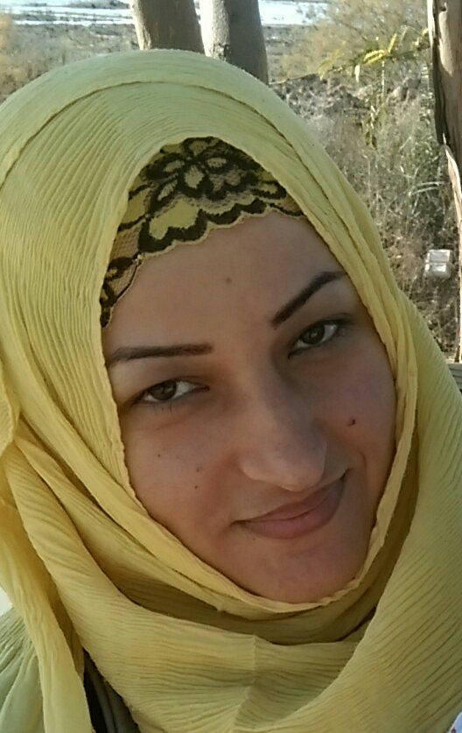

Personal details

Family name : AL - jarrah
Given names : Nibrass Shokee jalil
Gender : Female
Date of birth : 29/10/1982

Home address
City
Phone number
E-mail
Nationality
1: Iraq - Basra
: Basrah
: 07808349473-07717979755
: alnoorkhaled@yahoo.com
: Iraqi

Marital status
Children
1: married
: 3

Education
B.Sc. Translation from college of Art/Basra University

Courses and training:
WASH training course-SCI-Iraq-2013
CRSA training course - SCI - Iraq - 2014
KAP training course - SCI - Iraq - 2013

Objective:

I am looking for opportunity with an international company in Iraq requiring an admin work with can be part of the team able to develop himself and the crew around by having good communication ways with any kind of people and from any nationality following the company procedures that the company using it .

Work experience
Administrative worked in the: Iraq Human Rights Society
Employer : Save the Children International
Period: May 2013- now
Position: Child protection /Community Moblizer in Zubar
Employer: administrative

In 2009 I work as administrative in the FFA it is a chartable association my duties can be summarized as responsible of coordination of meetings, high calls, doing filing systems and translation

Other details
Languages:
-Arabic, mother tongue
- English (in word and writing)

Computer skills:
- Professional in Ms Office programs, Internet, e-mails-excel-Microsoft-word
- Professional in computer skills (software and hardware)
Hobbies:
- reading novels

Other details
Languages:
-Arabic, mother tongue
- English (in word and writing)

Computer skills:
- Professional in Ms Office programs, Internet, e-mails
- Professional in computer skills (software and hardware)

Hobbies:
- reading novels

